**Robert Heemann**

|  |  |  |
| --- | --- | --- |
| 2400 Waterview Pkwy Richardson TX, 75080 #1224 | [robert.heemann@utdallas.edu](mailto:robert.heemann@utdallas.edu) | 214-289-9949 |

|  |  |
| --- | --- |
| **Education** | Bachelor of Science, Electrical Engineering  University of Texas at Dallas, Richardson TX  Expected graduation: December 2019 |
|  | Highlighted Classes:  Digital Circuits (with Lab)  Signals and Systems (with Lab)  Electronic Devices (with Lab)  Electronic Circuits (with Lab)  Integrated Circuit Technology |

|  |  |
| --- | --- |
| **Experience** |  |
| Summer - 2018 | Web Services Student Worker, Erik Jonsson School of Engineering   * Updated and fixed web pages within the Erik Jonsson School of Engineering web site. * Coded the Mechanical Engineering Site redesign. * Learned and developed various professional and software skills.   Responsible for creating new websites for events and labs. This typically involved using templates from the Jonsson School, but some are original. |
| Fall 2018 | Office of Information Technology of the University of Texas at Dallas.   * Work as a “Computer Assistant” for the student labs on campus. * Kept labs clean and enforced rules. * Helped students and faculty with some IT related issues. |
| Summer 2017 | Host at Republic, 1836   * Learned valuable lessons like how to deal with upset customers, answer and talk on the phone, and how to work with other people who I may not always agree with. |

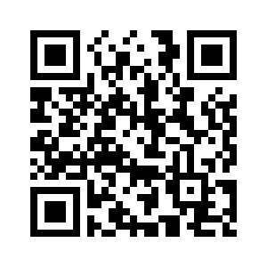

|  |  |
| --- | --- |
| **Skills** |  |
| Programming Languages | * HTML, CSS, JavaScript (Scan the QR Code to visit my personal website) * MATLAB * C, C++ * Python |
| Development Environments | Familiar Environments include   * Visual Studio * Visual Studio Code * Dreamweaver |
| Projects | I try to work on personal projects as time permits. I enjoy working with various microcontrollers and hope to work with *Internet of Things* enabled devices soon. I enjoy working with Digital Logic, but I have recently found interest in Digital Devices and Integrated Circuits. I hope to work on projects that introduce me to more topics in those areas.  I also enjoy working other, less technical projects like building furniture. |